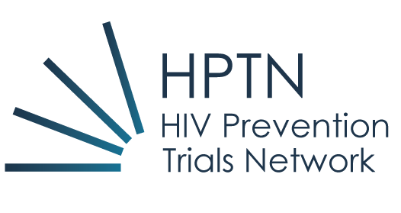

Call for Concepts for the NIH HIV Prevention Trials Network: April 2018

Dear Colleagues:

The HIV Prevention Trials Network (HPTN) is engaged in a large number of trials to reduce the transmission and acquisition of HIV. The trials are broadly divided into those focused on the development on non-vaccine HIV prevention agents as pre-exposure prophylaxis (PrEP) and integrated strategies designed to maximize the effectiveness of available HIV prevention tools. The trials cut across diverse at-risk populations and vary from exploratory vanguard studies to phase 3 randomized controlled trials. For further information, please visit the HPTN website at www.hptn.org.

We are eager to continue growing our scientific agenda and, thus, are writing to solicit submission of new concepts. This call for research concepts is broad and welcomed from either HPTN or non-HPTN affiliated investigators and can focus on any non-vaccine prevention method. The intent is to focus on identifying either new prevention interventions or combination of interventions that could have a positive impact on prevention of HIV transmission or acquisition. These could be vanguard studies (preparatory studies that aim to identify feasibility of recruitment and retention of potential study population, feasibility and acceptability of intervention or combination of interventions or exploring HIV incidence rates in specific population) or definitive phase 2 or 3 clinical trials.

Concepts should be limited to five pages and include the following information: brief background and rationale, target population, study design, key outcomes, study assessments, estimated sample size and potential impact on the target population. See the attached template.

Concepts should be received by HPTN by mailing to Kathy Hinson (khinson@fhi360.org) by August 15, 2018. These concepts will then be forwarded to the relevant HPTN scientific committee for review and prioritization (if more than one concept is reviewed). Following the scientific committee review process, the concepts will undergo the Network review by the HPTN Executive Committee as per HPTN’s established process. This process is anticipated to take place during the Fall of 2018. The process will include feedback to the concept authors.

Should you have any questions, please send your queries to Kathy Hinson at khinson@fhi360.org.

We look forward to hearing from you.

Sincerely,
Myron S. Cohen, MD Wafaa El-Sadr, MD, MPH, MPA
Co-Principal Investigator Co-Principal Investigator
HIV Prevention Trials Network HIV Prevention Trials Network

HIV Prevention Trials Network

STUDY CONCEPT PLAN

TITLE

DATE

HPTN STUDY CONCEPT PLAN

TITLE

CONCEPT DEVELOPMENT TEAM
(names and affiliations)

CONCEPT NOT TO EXCEED 5 PAGES

STUDY TITLE

SUMMARY OF PURPOSE AND RATIONALE: This should include introduction and background literature to set the context of the proposed research. Specify the principal aim(s), rationale, relevant background, overall design for Phase I/II trials describe critical pathway to efficacy evaluation; indicate relevance to the long-term global goals of HPTN.

STUDY AIM

STUDY OBJECTIVES

STUDY DESIGN
Specify the type of study proposed, e.g., whether it is a Phase I, IIA, IIB, or III randomized clinical trial, observational, nested case control study, etc.

Description of the INTERVENTION
Describe intervention (e.g. drug/regimen, counseling program), specify study arms, including control if applicable.

ENDPOINTS
Specify the primary endpoints such as seroconversion, dose-limiting toxicity, specific behavioral outcomes (either primary or secondary endpoints).

STUDY POPULATION
Specify sample size, the principal inclusion and exclusion criteria, recruitment source (s), appropriateness of the proposed study population for the proposed concept, and other salient characteristics.

PRODUCT-RELATED CONSIDERATIONS:
Is an IND needed? Is the product and placebo available in sufficient quantity for the proposed study? From whom? Is there a plan to manufacture sufficient quantities for any proposed follow-on studies?

TIMEFRAME:
Specify expected duration of accrual and follow-up, and any contingencies for development/implementation (e.g. final product selection/dosage to await results of ongoing study)

