HIV Prevention Trials Network (HPTN) 084 Publication Guidance
All manuscripts, abstracts, and presentations generated from HPTN research are subject to the HPTN Publication Policy, which is included as Section 21 of the HPTN Manual of Operations (https://www.hptn.org/resources/manual-of-operations). The purpose of this document is to outline additional procedures that have been developed specifically for abstracts, publications and presentations that arise from data generated from HPTN 084.
Collaboration
HPTN 084 is a collaborative study involving a number of entities:
- The HPTN, including the Statistical and Data Management Center (SDMC), the Laboratory Center (LC), the Leadership and Operations Center (LOC), and clinical research sites, is sponsored by the Division of AIDS (DAIDS), which is part of the National Institute of Allergy and Infectious Disease (NIAID) at NIH, with some funding provided by the Bill & Melinda Gates Foundation with study drugs provided by Gilead Sciences and ViiV Healthcare.
Plans for Data Analyses, Presentation, Abstract and Manuscript Development
It is the intention of the HPTN 084 Study Team that all the various entities involved in the study be engaged in the dissemination of findings through abstracts, presentations and publications. This effort involves the following principles:
- Abstracts, presentations and publications utilizing HPTN 084 data are presented and published in an expeditious manner.
- Writing assignments are clearly defined and agreed upon among HPTN 084 chairs and may include team members and collaborators.
- All HPTN 084 team members and collaborators are encouraged to propose concepts for development into abstracts, presentations and publications. The Protocol Chairs will approve or reject concept proposals.
- The process of selecting and prioritizing concepts for abstract, manuscript and presentation development will be transparent.
Publication Committee Members
The Chair and Co-chair of the study, in collaboration with the study’s senior statistician, will have the overall responsibility for spearheading and streamlining all abstracts, publications and presentations from HPTN 084. They will be assisted by an HPTN 084 Publications and Presentations (P&P) Group (084PubsCommittee@HPTN.org) that will help in the review of concepts, abstracts, presentations and manuscripts, as well as the prioritization process. The HPTN 084 P&P Group will also assist in the selection of manuscript writing groups taking into account individual contributions to the work and allowing for opportunities for individuals involved in HPTN 084 to participate in this effort.

The HPTN 084 P&P Group will consist of the following individuals:
- HPTN 084 Protocol Chair: Sinead Delany-Moretlwe
- HPTN 084 Protocol Co-Chair: Mina Hosseinipour
- HPTN Statistical and Data Management Center (SDMC) Representatives:
  - Protocol Statistician: Jim Hughes
  - Data Managers: Stephanie Orme and Priyanka Agarwal
- HPTN Laboratory Center (LC) Representatives:
  - HPTN LC Co-Director, HPTN Pharm Core Lead: Mark Marzinke
  - Senior QA/QC Coordinator: Estelle Piwowar-Manning
  - QA/QC Coordinator: Yaw Agyei
- HPTN 084 Medical Officer: Adeola Adeyeye
- HPTN 084 study team members ensuring one representative per country:
  - Harriet Nuwagaba-Biribonwoha, Joseph Makhema, Mina Hosseinipour, Nyaradzo Mgodi, Philippa Musoke, Sinead Delany-Moretlwe, Taraz Samandari
- Other individuals who may be called upon in an ad hoc manner to participate in the process as needed (representatives from Bill & Melinda Gates Foundation, Gilead Sciences, ViiV Healthcare, or other experts)
- HPTN Leadership and Operations Center (LOC)/Group Facilitators:
  - Clinical Research Operations Manager: Scott Rose
  - Clinical Research Operations Manager: Jennifer Farrior
  - Clinical Trials Assistant: Jill Stanton
Manuscript Writing Group
After Protocol Chair approval of a concept, each Manuscript Writing Group will be established and approved by the HPTN 084 P&P group in consultation with the Protocol Chairs. The Writing Group will be chaired by the designated lead author. The lead author will be responsible for establishment of a timeline for the manuscript development process, ensuring adherence to the timeline, facilitating appropriate reviews and approvals by the HPTN 084 P&P, the HPTN manuscript review committee and obtaining concurrence from all coauthors. A representative from the SDMC will be included as part of each manuscript writing team that involves study data. At least one member of the HPTN LC will also be included as part of the manuscript writing team for all manuscripts that include laboratory data. If the lead author or any other member of the writing team is unable to deliver on their responsibilities, they will be replaced after discussion with the HPTN 084 P&P.
Lead authors are invited to attend HPTN 084 Publications Committee calls to provide progress updates and to seek input and discussion from the Committee. If a lead author cannot join a call, s/he should ask a co-author to attend to provide an update. If neither the lead author or a co-author can attend, the lead author is asked to provide a written update to the committee.
Guidance for Authorship
The following is suggested guidance on authorship for HPTN 084 abstracts, publications and presentations:
- Authorship should be reflective of the key role of individuals in various aspects of the study, of the multi-site nature of HPTN 084 and the publication policies of the HPTN.
- Authorship should be reflective of the generally accepted authorship guidelines for peer-reviewed journals. As such, authorship should be based on substantial contributions to conception and design, acquisition of data, or analysis and interpretation of data; drafting the manuscript or revising it critically for important intellectual content; and final approval of the version to be presented/published.
- The designated lead author should be the first author of the manuscript. Other authors should reflect the writing team and acknowledge key contributions in the design and implementation of the study, analysis, and interpretation. A representative from the HPTN LOC and DAIDS should be considered as authors on appropriate abstracts/manuscripts.
- For manuscripts that involve data from multiple sites, the Manuscript Writing Group should include some representation from the participating sites. All efforts will be made to ensure parity over time. All authorship lists for manuscripts that include data from more than one site should include “on behalf of the HPTN 084 Study Team” at the end of the authorship list. The acknowledgement section or supplementary appendix of the manuscript should include the name of at least one individual from each participating site. The site IoR is responsible for designating the most appropriate site representative to be listed as a member of the HPTN 084 Study Team.
- HPTN 084 is a multicenter study, thus, no data from a single site that involves components of the study may be presented or submitted for publication prior to presentation and/or publication of the overall study component results (Primary Manuscript). Once the overall results are made public through presentations/publications, proposals may be submitted for presentation or publication of single site data analyses by following the Concept Submission procedure.
Submission of Abstracts and Concepts for Publications
Draft abstracts and concepts for publications regarding HPTN 084 should be submitted for consideration utilizing the concept submission form below when applicable (Appendix 2). These include proposals for both multi-site and single-site analyses. As previously stated, the HPTN 084 Chairs will review and prioritize such requests based on scientific merit and feasibility.

Review and Approval
All HPTN 084 abstracts and manuscripts must be reviewed by the HPTN 084 P&P prior to submission. In addition, abstracts and manuscripts must be reviewed by the HPTN manuscript review committee (MRC) according to the HPTN Publication Policy. As such, all abstracts and manuscripts must be reviewed by the HPTN Manuscript Review Committee (MRC) prior to submission. The MRC reviews manuscripts within 10 working days of receipt with the following possible outcomes:
- Recommend for submission
- Recommend for submission with consideration of comments

- Not recommended for submission in its current form (with comments from reviewers)

- MRC review not required (Note: MRC review will be required for HPTN 084)
All abstracts will be reviewed within three working days.
Submission to the MRC must be accompanied by a submission form which is located here:

https://www.hptn.org/resources/MRCSubmissionForm

For major scientific conferences (e.g., CROI and IAS), abstracts will be submitted to the MRC in batches which may add a few additional days to the review process.

Additionally, all abstracts, presentations and manuscripts should be reviewed by the relevant pharmaceutical companies and funders.

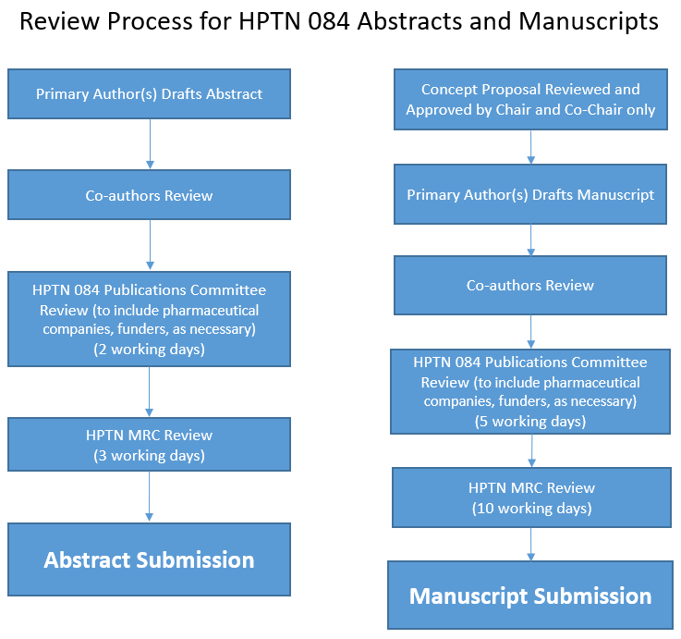
Review Process for HPTN 084 Abstracts and Manuscripts
Appendix 1

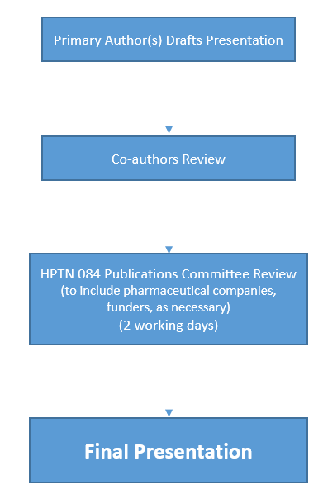
Review Process for HPTN 084 Conference Presentations
(Posters and Slide Sets)

Appendix 2
HPTN 084 Publications Concept Proposal Form

Date: ____________

Submitter name: __________________________________

Submitter institution: _____________________________

Submitter email address: ___________________________

This proposal should be brief (1-3 pages) and include the following:

- Proposed presentation/abstract/manuscript title and names of the lead author as well as potential participating authors (if known).

- Specify the meeting for presentation or abstract submission, or target journal for publication.

- Briefly describe the rationale for the proposed concept.

- Describe major goals of your proposal.

- Provide details of the proposed outcome(s) and independent variables of primary interest (e.g. risk factors) that support the analysis for the major goals,

- List study sites from which data will be used for the proposed analysis.

- Proposed timeline for completion of analysis.

- OPTIONAL: Most analyses will be performed by the HPTN Statistical and Data Management Center (SDMC). Exceptions should indicate the statistical methods/approaches anticipated for the manuscript and reasons why the analysis should be performed without the SDMC’s involvement.

Submit this Proposal Form to Scott Rose (srose@fhi360.org) and Jennifer Farrior (jfarrior@fhi360.org), cc’ing Sinead Delany-Moretlwe (sdelany@wrhi.ac.za) and Mina Hosseinipour (mina_hosseinipour@med.unc.edu).

